Concrete Resources

The following resources are regularly used to support the teaching and learning of mathematics across the whole of Stony Dean. These are not the only resources we use but they are used more regularly than other resources and are vital in the teaching of number work.
We use a variety of resources to ensure that all pupils can access the maths curriculum and different resources are used to teach specific mathematical concepts.
Numicon
Numicon is a multi-sensory resource that we use to help our pupils recognise numbers and understand connections between numbers.
This resource is heavily used in KS3 and in the Foundation Department.

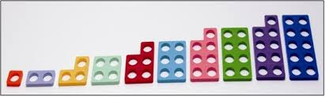

Ten Frames

Ten Frames are another resource that we use in order to develop number sense and place value.

Dienes
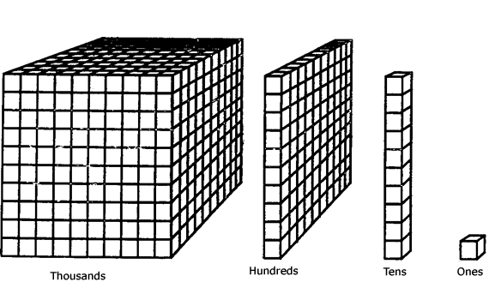
Dienes are also referred to as Base Ten Blocks. They are a vital resource that we use at Stony Dean in order to support and develop understanding around the basic principles of number work – number sense, place value and the four number operations but in particular addition and subtraction.
Dienes are regularly used in most maths classes.
Dien

Place Value Boards
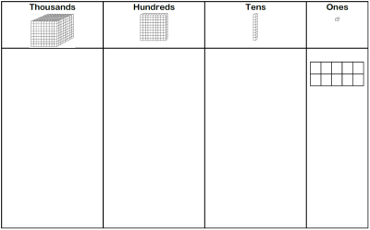
Once pupils have mastered using the Dienes they begin to work on the place value boards with Dienes.
The place value boards reinforce the concepts taught with Dienes and support the transition from using concrete resources to pictorial resources.

Number lines/Rulers
Number lines and rulers are consistently used in all lessons to support number recognition and mental addition and subtraction calculations.

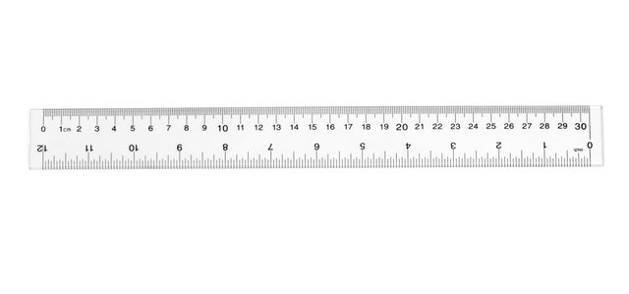
Place Value Arrow Cards
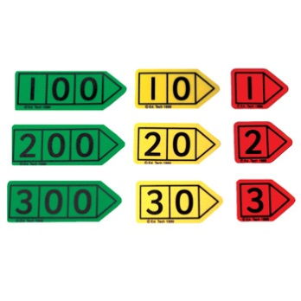
By using place value cards, pupils gain a deeper understanding of the value of each digit and how to write in numerals numbers from 1 digit to beyond a million.

Place Value Dice
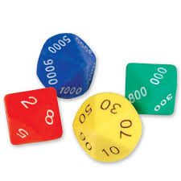
Place value dice are often used in conjunction with the place value cards, not only are they a valuable resource with regards to understanding number they allow our pupils to generate their own numbers and therefore encourage greater independence.

Place Value Counters
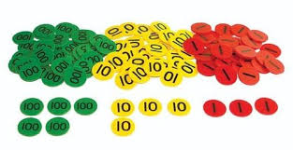
Place value counters are usually introduced to our pupils once they are secure in using Diene Blocks. They are used to extend the understanding of the four number operations – addition, subtraction, multiplication and division.

