Mathematics Department – February, 17 Bulletin

One of the things the maths department prides itself on is using something called the Concrete, Pictorial and Abstract (CPA) Model for teaching maths. This means that we always start with physical resources to introduce a new concept or activity. We build up understanding through the use of resources that can be used by all our pupils before then moving onto using pictures or images to support the development of the idea our pupils are learning. We then finally move onto the abstract form of maths, which is basically all our learners applying what they have learnt using a written format.

The photographs below are taken from a maths group who have started a data handling project this week and demonstrates this CPA model in action.

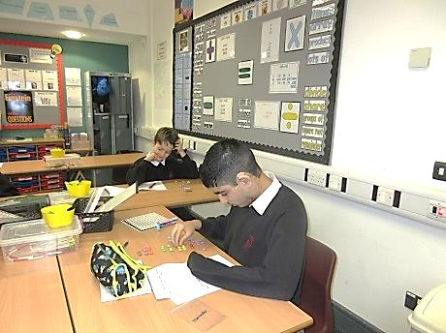

After a short discussion about the project, each learner is given a pack of smarties to sort out into groups of colours. They then produced a tally chart for each colour.

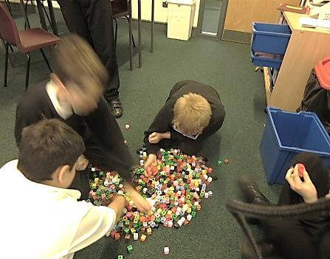
Next, each learner had to get some cubes in order to make a physical bar chart.

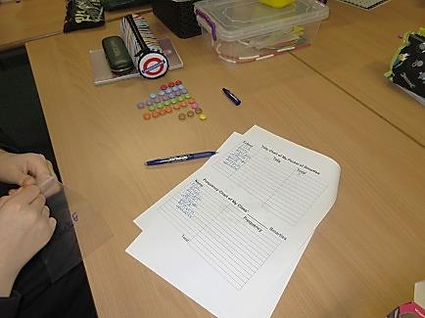
Once the cubes were collected, the making of the bar charts began.

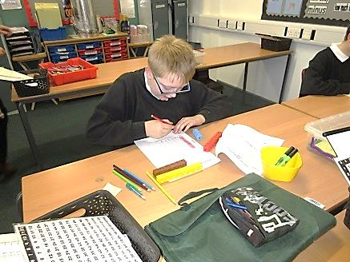
Using the bars they made, this information was then transferred into a bar chart that was recorded in a written format.

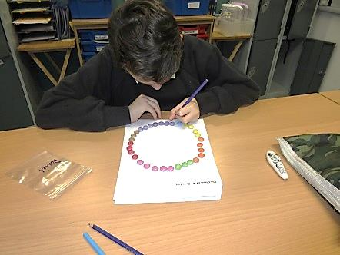
After completing bar charts the group moved onto making pie charts. Having grouped the smarties into colours they formed a circle with them and then on the outer edge of their ring of smarties they coloured in small circles to complete their written pie chart.

The final stage of their pie chat is then made by colouring in a strip of paper that matches the amount of the smarties they have. Once this strip has been finished, the group will have each end glued together to make a 3-D ring as another way of making a pie chart.
Once all the graph work has been finished this group will explore fraction quantities of smarties and working out costs and change from buying packets of smarties.

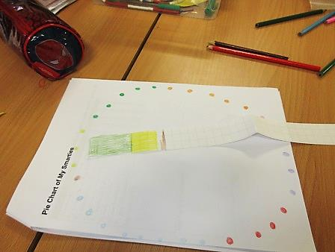

This is just one example of how we build up mathematical concepts in lessons at Stony Dean throughout all classes, year groups and key stages.

