SUGGESTED TEXT FOR PARTNER SCHOOL WEBSITES
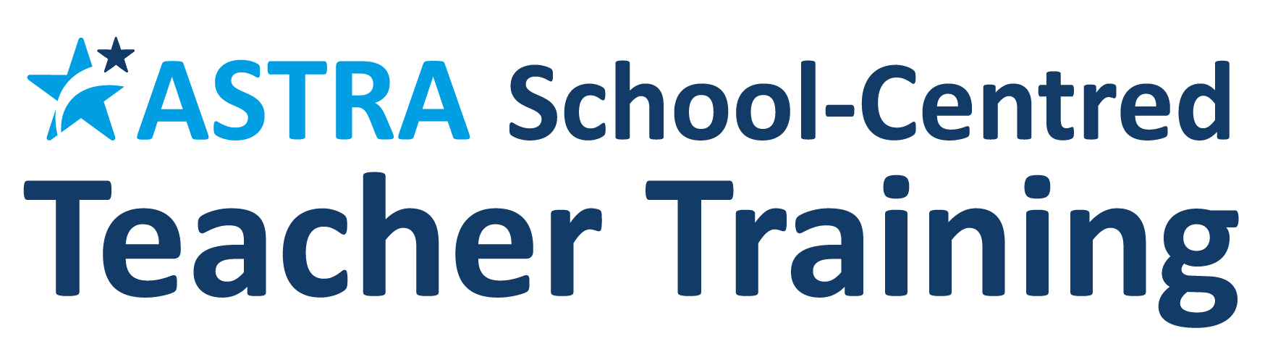
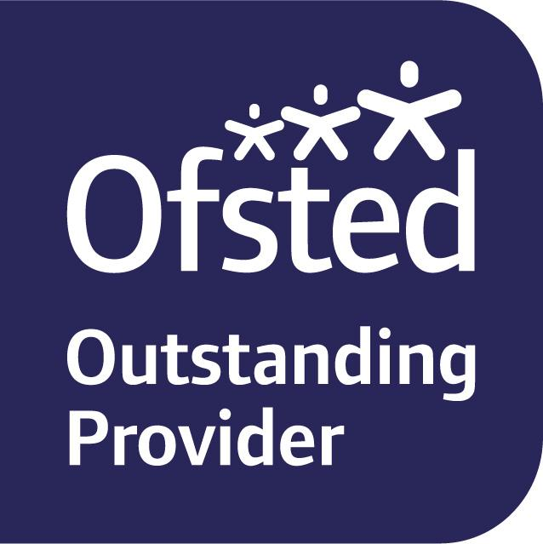

Train to Teach with us in 2019/20!

This year, Stony Dean is thrilled to be offering bursary led/QTS and PGCE teacher training places for 2019-2020, in partnership with the Astra SCITT. Astra has recently (November 2018) been judged as ‘outstanding’ by Ofsted in all four categories for initial teacher training. The full Ofsted inspection report is available via the Astra website (www.astra-alliance.com) or this link to the Ofsted website.

For 2019/20, the following bursary-led / unsalaried training places are available at our school:
English and Maths.

Generous, tax-free bursaries are available for some subjects and a full list of these can be seen via this link.

We also offer salaried training placements in the following subjects: Maths

As well as awarding QTS through Astra’s weekly core training programme, the SCITT also works with Goldsmiths, University of London for the optional PGCE ‘top up’ qualification, worth 60 Masters credits.

Since 2013, the Astra partnership has considerable experience of training teachers and recognises and values the enthusiastic contribution that they make to our school communities. Employment rates for trainees are high and outcomes and completion rates are also well above national benchmarking figures. Expert staff in our schools share their knowledge and good practice to ensure that trainees are well supported to develop into good and outstanding teachers. We also aim to ensure the right trainee is matched to the right school for both the main and second teaching placements.

To find out more, please contact Mrs J Dwyer or speak to a member of the Astra SCITT team via hello@astra-alliance.com / telephone 01494 787573. Please also click here to access the ASTRA prospectus. Details of forthcoming open days and events can be found on the Astra website.

