Website Info – Design & Technology / Food Technology

Course Overview – Resistant Materials

**KS3**

In Key Stage 3 Technology, pupils study Resistant Materials and Food Technology in rotation during the school year:

The programme of study in Resistant Materials seeks to increase their knowledge and understanding of the subject through the designing and making of products, in line with the KS3 National Curriculum objectives. Students will explore what Design & Technology is all about and why it is important. They will build on basic practical skills and technical vocabulary

Year 7 – Key Fob Project Travel Puzzle Project

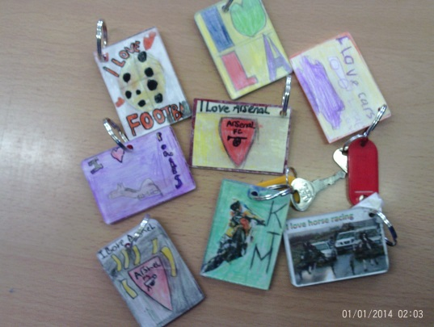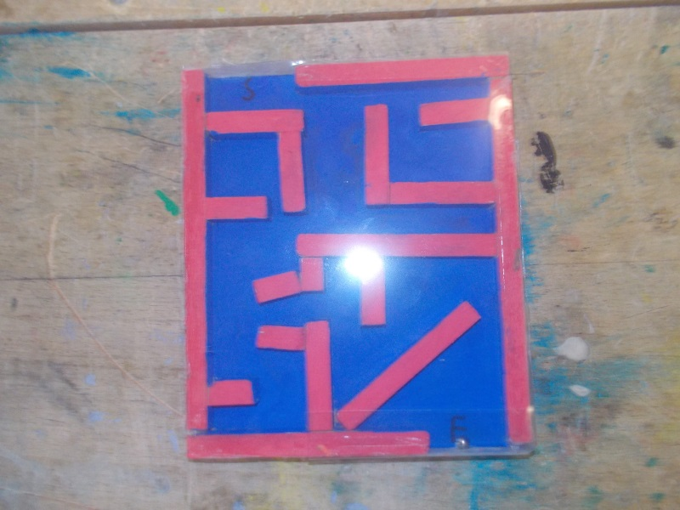

Year 8 – Bookends Project (Structures)

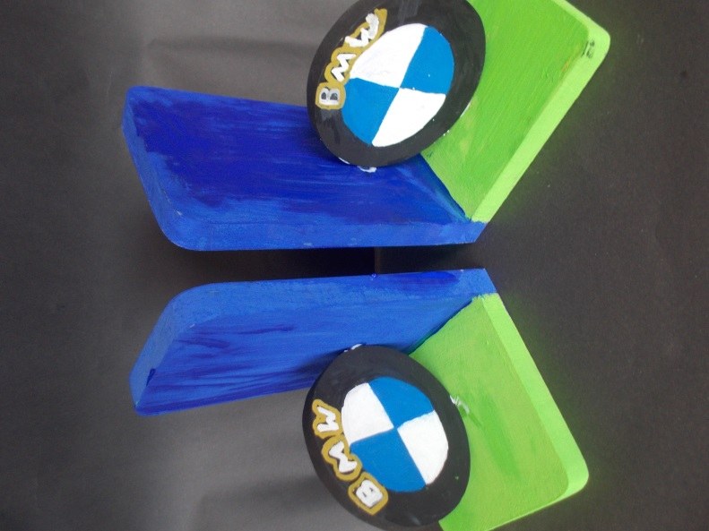 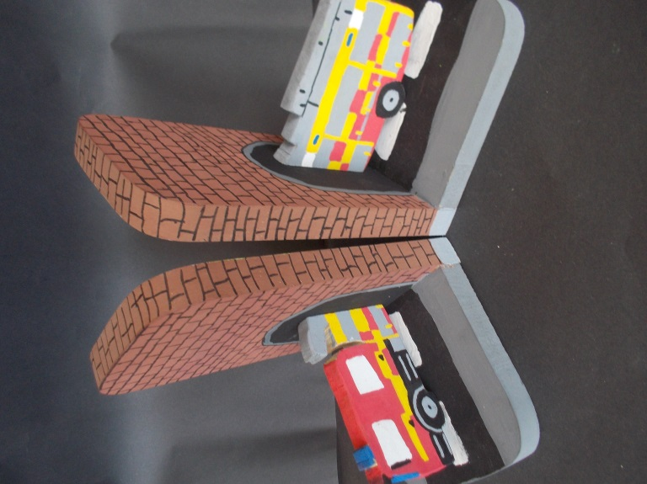

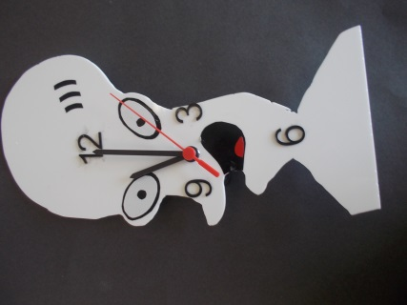Year 9 – Clocks and mechanisms

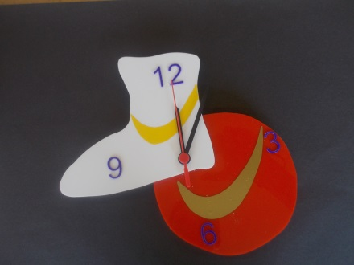

KS4

Students develop their practical skills further by designing and making products based on a user’s needs.

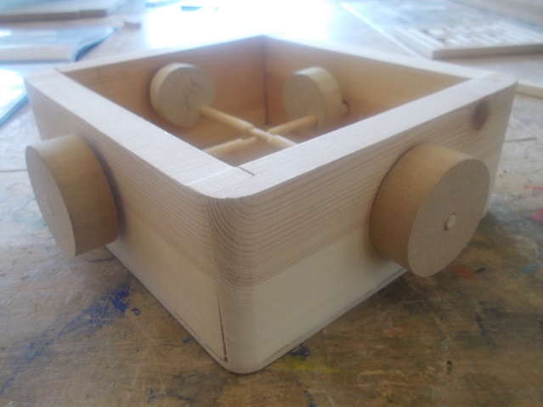 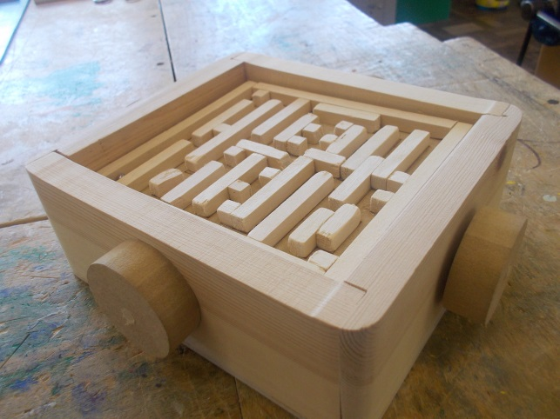

Brio Labyrinth Project (understanding joints, motion and mechanisms, cams)

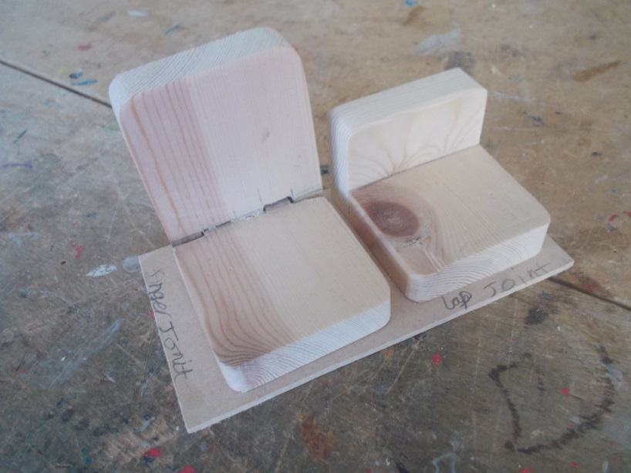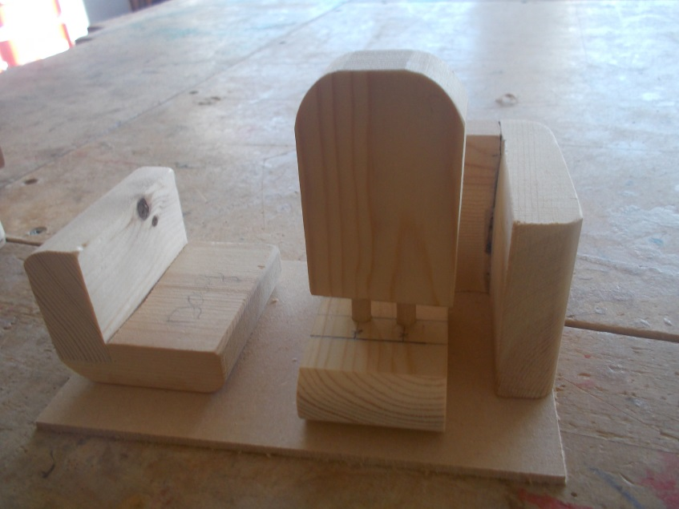

KS4 &5 BTEC (Yr10/11/12)

Students undergo the BTEC Construction Entry Level (E3) course from Year 10. They complete 2 units which is internally moderated and assessed.

**Unit 1:** Producing a timber product (Tray)

This unit is designed to enable learners to produce a three-dimensional timber product (for example tray, picture frame, mirror frame). Learners will develop the skills needed to manufacture a product in timber and timber sheet materials.

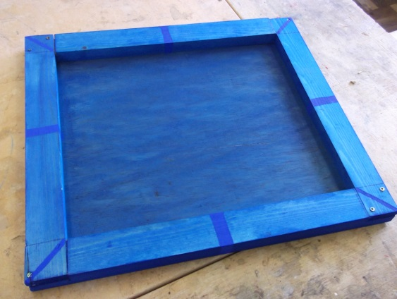

**Unit 3:** Developing home improvement skills (Hanging a picture frame and a shelf)

This unit introduces learners to the hand tools, materials, components, fixings and personal protective equipment used in home improvement, and offers learner’s opportunities to develop the skills needed to make home improvements.

[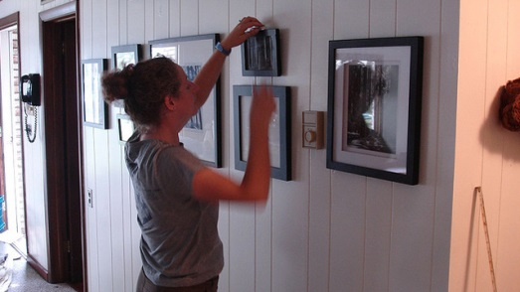](http://lifehacker.com/5829198/how-to-hang-pictures-without-destroying-your-walls)

Food Technology KS4/5 BTEC

**BTEC Jamie Oliver**: Home Cooking Skills Level 1 &2

This unit aims to give learners the knowledge, skills and confidence to enjoy cooking meals at home. Learners will gain understanding of how to economise when planning meals to cook at home. The unit will encourage learners to transfer skills learnt to other recipes to continue cooking for themselves and their families and to inspire others by passing on their knowledge.

The unit is based on the chef Jamie Oliver’s proposition that being able to cook is an essential life skill which empowers people to make changes that have benefits to health and wellbeing.

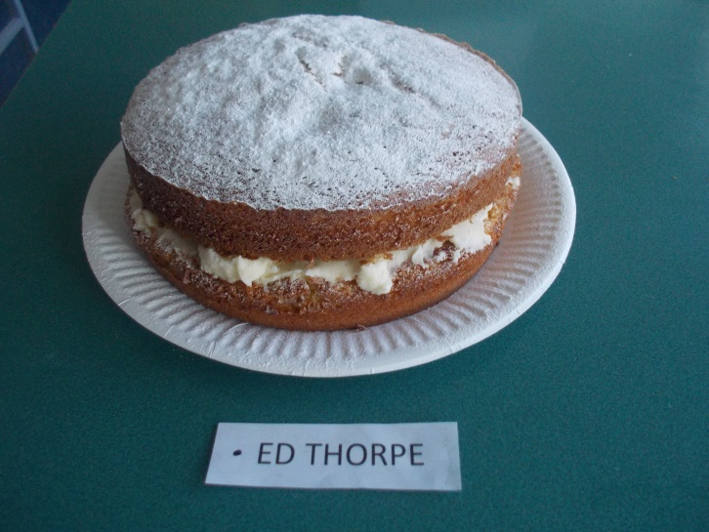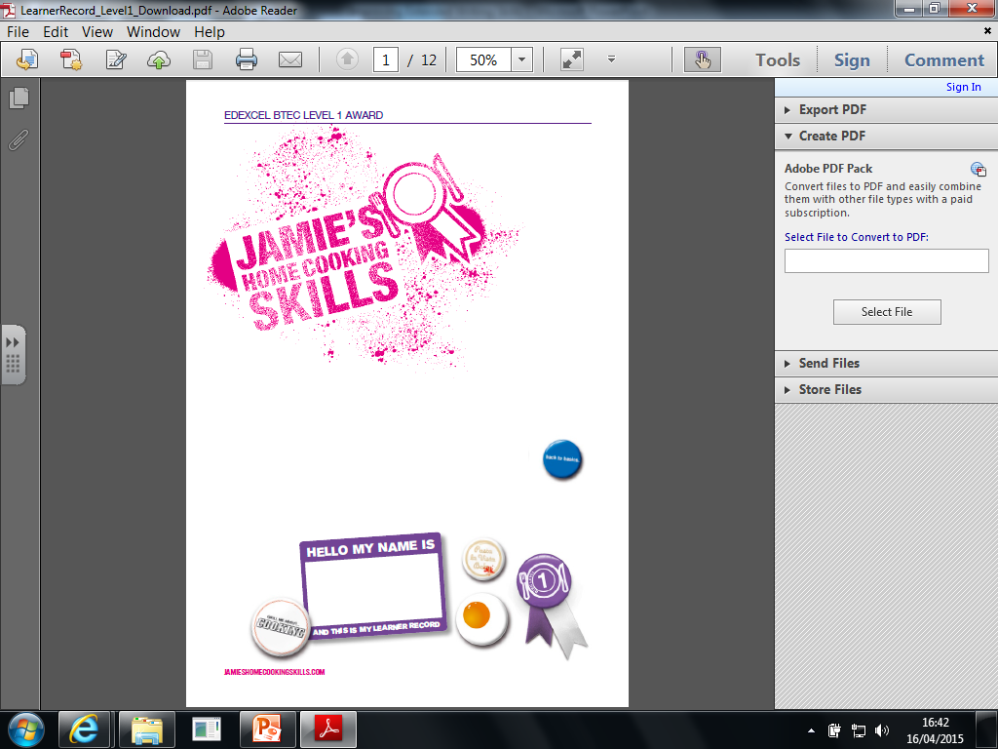

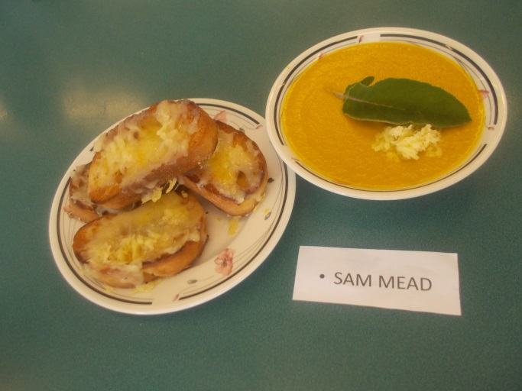

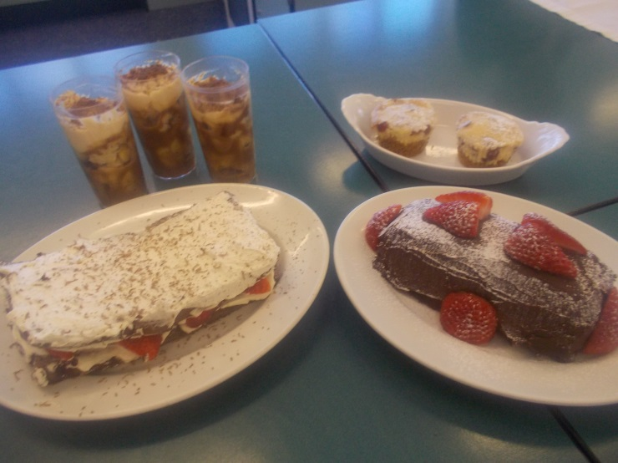

Assignment Tasks

