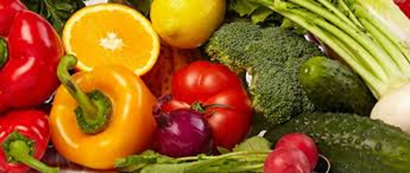
Foundation and Vertical Groups -
Pupils are introduced to the fundamentals of Food Technology. Each term they are given a different topic to look at. This will be Healthy Breakfasts, Healthy Lunches and Healthy Dinners. Pupils will begin to look at different food groups, the eat healthy plate and budgeting.

Year 7 –
Pupils will be introduced to the fundamentals of food technology. This will include understanding the importance of good kitchen hygiene and kitchen safety. Pupils will then go onto making a number of dishes including sandwiches toasted and non-toasted and various wraps. This allows pupils to understand the eat well plate and be able to independently create healthy dishes and snacks.
Pupils will also become familiar with catering basics such as; knife skills, equipment and food storage.

Year 8 –
Pupils will be introduced to the fundamentals of food technology. This will include recapping the importance of good kitchen hygiene and kitchen safety. Pupils will then go onto making a number of dishes including soups, salads and sweet and savoury pies. This allows pupils to understand the eat well plate and be able to independently create healthy dishes and snacks.
Pupils will also become familiar with catering basics such as; knife skills, equipment and food storage.

Year 9 –
Pupils will be introduced to the fundamentals of food technology. This will include recapping the importance of good kitchen hygiene and kitchen safety. Pupils will then go onto making a number of dishes including pasta, stir fries and healthy snacks. This allows pupils to understand the eat well plate and be able to independently create healthy dishes and snacks.
Pupils will also become familiar with catering basics such as; knife skills, equipment and food storage.

Year 10 and 11
Pupils in Year 10 and 11 are given the option of 2 subjects that they would like to study in Year 10 and 11 out of Food Technology, Design Technology and Art. Pupils will then have 1 lesson of their first choice and 1 lesson of their second choice. Pupils will then be given a life skills based lesson on a carousel basis. Pupils are expected to go home and with support cook for their family using the recipe cards provided by the school.

Year 10 and 11 Options-
Pupils in Year 10 and 11 will explore a large amount of world cuisines. Pupils will be taught how to recognise and cook with different ingredients from around the world. Pupils will also become competent in cooking meal for people with allergies and different food lifestyles.
In addition to this pupils will research and evaluate different dishes and as we progress throughout the year, pupils independence in the kitchen will increase and staff support will decrease. Pupils will be asked to create or follow dishes from cookbooks or from the internet as well budget and prepare themselves and their environment for cooking. Pupils in year 10 and 11 will look at;
- Potatoes and Leftovers
- Mince
- Vegetables and Pulses
- Greek and Italian Cuisine
- Chinese and Indian Cuisine
- Western Food

Year 10 and 11 Life skills -
Pupils in Year 10 and 11 life skills will be cooking every lesson. This lesson is about getting pupils ready and confident to live independently. Pupils will plan, create, cook and evaluate dishes. We expect all pupils to try new things and participate in the theory as well as the practical based content.

